Kindergarten Choice Board-June 8
Making Ten  Turn over 20 cards from a deck. Find pairs of cards that make 10 by counting the shapes on the cards. How many pairs can you make?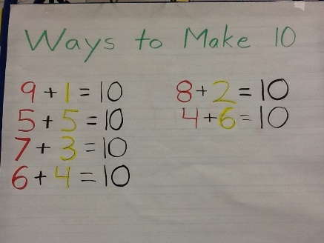 | Mrs. Madore  French Flora activity for K-4 students.  Go to Level 2, module 3  Listen to the dialogue 1(find items), 2(choose a place in your house),  3 (choose a member in your family) to learn what’s in your house. https://flora.nbed.nb.ca | One more or one fewer-Pair up!  Using a deck of cards (A-9) count out 10 cards-draw pile. Turn the other cards face up on the table. Turn over one card in your draw pile. Find a face up card that is one more. Play until your draw pile is gone. Replay doing it pairing up for one fewer.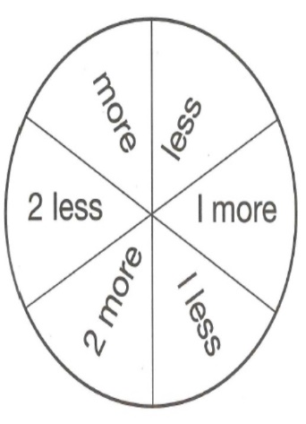
Read, Read, Read!!!  Read the road signs as your driving, read the sale sheets, read a magazine, read books, inside-outside, in a fort, under your bed, in the car...READ EVERYWHERE  https://www.getepic.com | Patterns  Use a deck of cards to create a pattern.  5, 4, 5, 4, 5  Red, Black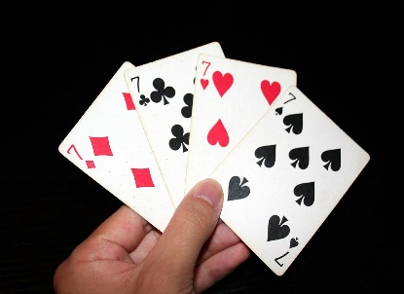  Diamond, spade, spade, | Mail time!  Write a letter to a family member or neighbor. Seal it in an envelope and write their name on the outside. Hand deliver it to them and ask them to write you back!

